17.46: a) Let the man be designated by the subscript m and the “‘water” by w, and T is the final equilibrium temperature.

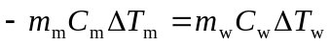
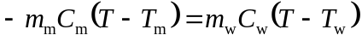
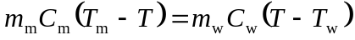
Or solving for T, 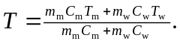 Inserting numbers, and realizing we can change K to 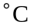, and the mass of water is .355 kg, we get
Thus, 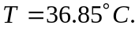

b) It is possible a sensitive digital thermometer could measure this change since they can read to 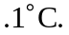 It is best to refrain from drinking cold fluids prior to orally measuring a body temperature due to cooling of the mouth.

